

**Certificate in Junior Python Data Analyst**

**Project Title: Data Analysis on Unicorn Companies**

**Lecturer: Ivan LAW**

**Members: Pang Hoi Him 13**

**Leung Chi Wa 21**

**Date: 18 July 2025**

Table of Contents

1. Abstract 5

2. Executive Summary 5

3. Objectives 6

4. Methodology 6

5. Expect Outcomes 6

6. Exploratory Data Analysis 8

6.1 Industry-Based Analysis 8

6.1.1 Distribution of Companies across Different Industries 8

8

Bar Chart Analysis: *Distribution of Companies by Industry* 9

Key Observations 9

Enterprise Tech (32.5%) 9

Industrials (16.2%) 9

Consumer & Retail (14.7%) 9

Healthcare & Life Sciences (9.5%) 9

Media & Entertainment (6.8%) 10

Insurance (2.0%) 10

Conclusion 10

6.1.2 Distribution of Equity Funding across Different Industries 11

6.2 Geographical Analysis:- Top Countries by Valuation 13

Top Countries by Startup Valuation & Company Count 13

Chart 1: Latest Valuation (in B$) 13

Chart 2: Number of Companies 14

Key Insights 14

United States 14

China 14

India 14

Europe (UK, Germany, France) 14

Others (e.g., Israel, Brazil, Singapore) 14

Conclusion 15

6.3 Sector-Based Analysis (Top Sector) 16

Chart 1: Total Valuation by Sector 16

Insights: 17

Chart 2: Number of Companies by Sector 17

Insights: 17

Valuation Efficiency: Average Valuation per Company 18

Conclusion 18

6.4 Company-Based with Growth Rate Analysis 19

Top Companies by Valuation (2024 vs. 2025) 19

Growth Rate Highlights (Bottom Section) 20

Observations: 20

Conclusion 20

6.5 Top Investor Analysis 22

Chart 1: Valuations of Invested Companies ($B) 22

Key Observations: 22

Chart 2: Number of Companies Invested 23

Key Observations: 23

Conclusion 23

6.6 Top Founder Analysis 24

Key Observations 24

Conclusion 25

7. Time-Based Analysis 26

Graph Analysis: Unicorn Growth Over Time (2007–2024) 26

🔹Cumulative Growth (Line with Pink Dots) 26

🔹 New Unicorns Per Year (Bar Graphs) 26

Interpretation & Trends 27

Conclusion 27

1. VC Capital Overflow 27

2. Pandemic-Driven Digital Acceleration 27

3. AI & Deep Tech Investment Wave 27

4. SPAC Mania & IPO Pipeline 27

5. Globalization of Startup Ecosystems 28

6. Fear of Missing Out & Deal with uncontrolled and excited behaviour 28

**Summary** 28

Graph Overview 29

Key Insights 29

1. Fastest Growth Window: 2–6 Years 29

2. Enterprise Tech Dominates Early Success 30

3. Industrials and Healthcare Take Longer 30

4. Long Tail of Growth (10+ years) 30

Conclusion 30

8. Survival and Acquisition 31

Graph Analysis: Top Exited Unicorns 31

**🔹** 1. Instacart ($39B) 31

**🔹** 2. FTX ($32B) 31

**🔹** 3. J&T Express ($20B) 31

**🔹** 4–11. Clustered $10B Unicorns 32

**🔹** 12–20. Valuations Between $6B–10B 32

Conclusion 32

Graph Breakdown: Exit Pathways for Unicorns 33

Insights 33

1. IPO Is the Dominant Exit Route 33

2. Acquisition Is the Second Most Common 33

3. Mergers Are Less Prevalent 34

4. Rare and Risky Outcomes 34

Conclusion 34

9. Significance 35

10. Conclusion 35

# 1. Abstract

This study conducts an in-depth analysis of privately held startups with valuations exceeding one billion US dollars—commonly known as "unicorn companies"—using Python as the primary tool to explore their growth patterns and underlying driving forces. The project aims to extract key insights from the unicorn ecosystem and visually present core trends in areas such as industry distribution, geographic concentration, valuation dynamics, and funding behavior.

It emphasizes how Python techniques can transform raw, complex data into structured and easily interpretable information, thereby enhancing the quality of presentations and deepening understanding of startup dynamics among decision-makers, investors, and entrepreneurs.

Through cross-variable analysis—such as the relationship between funding scale and valuation, or the time-series trend of unicorn formation—this study also uncovers the hidden correlations and influential factors behind startup success.

The findings not only demonstrate data science capabilities, but also provide a valuable toolkit for venture capital decision-making, industry assessment, and policy formulation.

# 2. Executive Summary

This project aims to conduct a comprehensive data analysis of unicorn companies—privately held startups valued at $1 billion or more—using Python, leveraging skills acquired through academic coursework. The primary objective is to utilize Unicorn’s data for data analysis and to generate insightful visualizations that reveal trends, patterns, and relationships within the unicorn ecosystem. The analysis will focus on key metrics, including company valuations, industries, geographic distribution, founding years, and funding amounts, to provide a clear understanding of the factors which can provide more information for investors to make decision for the investment of startups companies.

# 3. Objectives

1. **Data Exploration and Cleaning**: Import and preprocess a dataset of unicorn companies, addressing missing values, standardizing formats, and ensuring data quality for accurate analysis.
2. **Visualization Development**: Create a variety of graphs, such as bar plots, histograms, box plots, scatter plots, and line charts, to illustrate the distribution of unicorns by industry, country, valuation trends, funding patterns, and growth over time.
3. **Insight Generation**: Identify key trends, such as dominant industries, leading geographic hubs, and correlations between funding and valuation, to inform stakeholders about the unicorn landscape.
4. **Presentation of Findings**: Produce clear, professional visualizations suitable for inclusion in reports, presentations, or strategic discussions, making complex data accessible to diverse audiences.

# 4. Methodology

The project will use a structured approach:

1. **Data Acquisition**: Source a dataset of unicorn companies from Kaggle containing columns like company name, valuation, industry, country, founding year, and total funding.
2. **Data Processing**: Employ pandas to clean and preprocess the data, handling missing values, converting data types, and removing duplicates to ensure reliability.
3. **Exploratory Data Analysis (EDA)**: Conduct initial analysis to summarize key statistics, such as mean valuations, industry counts, and geographic distributions.
4. **Visualization**: Generate graphs using matplotlib and seaborn, including:
   * Bar plots to show the number of unicorns by industry and country.
   * Histograms to depict valuation distributions.
   * Box plots to compare valuations across industries.
   * Scatter plots to explore relationships between funding and valuation.
   * Line charts to track the growth of unicorns over time.
5. **Interpretation**: Summarize findings, highlighting actionable insights, such as emerging industries, key markets, or factors influencing high valuations.

# 5. Expect Outcomes

The project will deliver a comprehensive set of visualizations and insights that illuminate the unicorn company landscape. Key deliverables include:

* A cleaned and processed dataset ready for analysis.
* A series of professional-grade graphs saved as JPG files for presentations or reports.
* A summary of findings, identifying dominant industries (e.g., FinTech, AI), leading countries (e.g., USA, China), valuation trends, and potential correlations between funding and valuation.
* Recommendations for stakeholders, such as investors or policymakers, based on observed trends, such as focusing on high-growth sectors or regions.

# 6. Exploratory Data Analysis

# 6.1 Industry-Based Analysis

# 6.1.1 Distribution of Companies across Different Industries

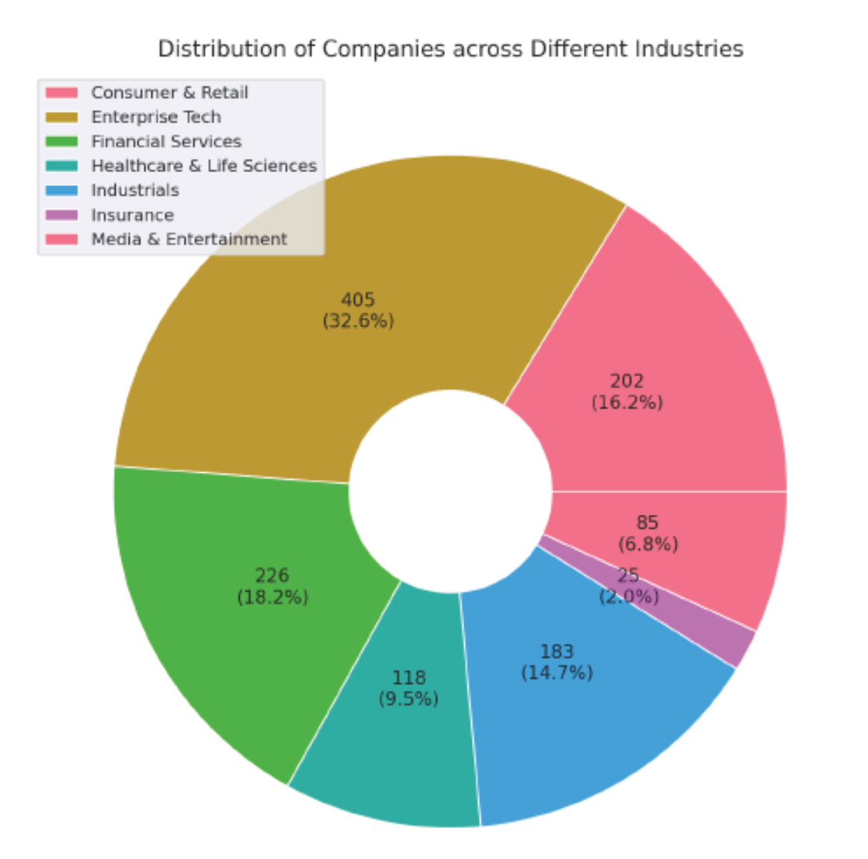

Bar Chart Analysis: *Distribution of Companies by Industry*

The chart displays the **number of companies** in each industry out of a total of **1,244 companies**. Here's the corrected breakdown:

| **Industry** | **Number of Companies** | **Percentage (%)** |
| --- | --- | --- |
| Enterprise Tech | 405 | 32.5% |
| Financial Services | 226 | 18.2% |
| Industrials | 202 | 16.2% |
| Consumer & Retail | 183 | 14.7% |
| Healthcare & Life Sciences | 118 | 9.5% |
| Media & Entertainment | 85 | 6.8% |
| Insurance | 25 | 2.0% |

Key Observations

Enterprise Tech (32.5%)

* The largest segment by far.
* Reflects the dominance of software, cloud, AI, and digital infrastructure companies.
* Indicates high scalability and investor interest in tech-driven solutions.

Financial Services (18.2%)

* A strong second place.
* Includes fintech, payments, lending, and wealth management platforms.
* Suggests ongoing disruption of traditional finance.

Industrials (16.2%)

* A surprisingly large share.
* Likely includes logistics, manufacturing tech, robotics, and supply chain platforms.
* Shows that innovation in physical infrastructure is gaining traction.

Consumer & Retail (14.7%)

* Slightly smaller than expected.
* Indicates a more selective or mature market compared to tech and finance.

Healthcare & Life Sciences (9.5%)

* A steady presence.
* Reflects the complexity and regulatory intensity of the sector, despite high impact potential.

Media & Entertainment (6.8%)

* A modest slice.
* May reflect challenges in monetization, IP, and platform saturation.

Insurance (2.0%)

* The smallest category.
* Suggests high barriers to entry or slower innovation cycles in insurance.

Conclusion

* **Enterprise Tech dominates** the startup landscape, accounting for nearly one-third of all companies—underscoring its central role in modern innovation.
* **Financial Services and Industrials** are also robust, reflecting strong momentum in fintech and infrastructure modernization.
* **Consumer & Retail and Healthcare** remain important but are relatively smaller, possibly due to market maturity or regulatory complexity.
* **Media & Entertainment and Insurance** are niche sectors with fewer players, potentially signaling untapped opportunities or structural challenges.

# 6.1.2 Distribution of Equity Funding across Different Industries

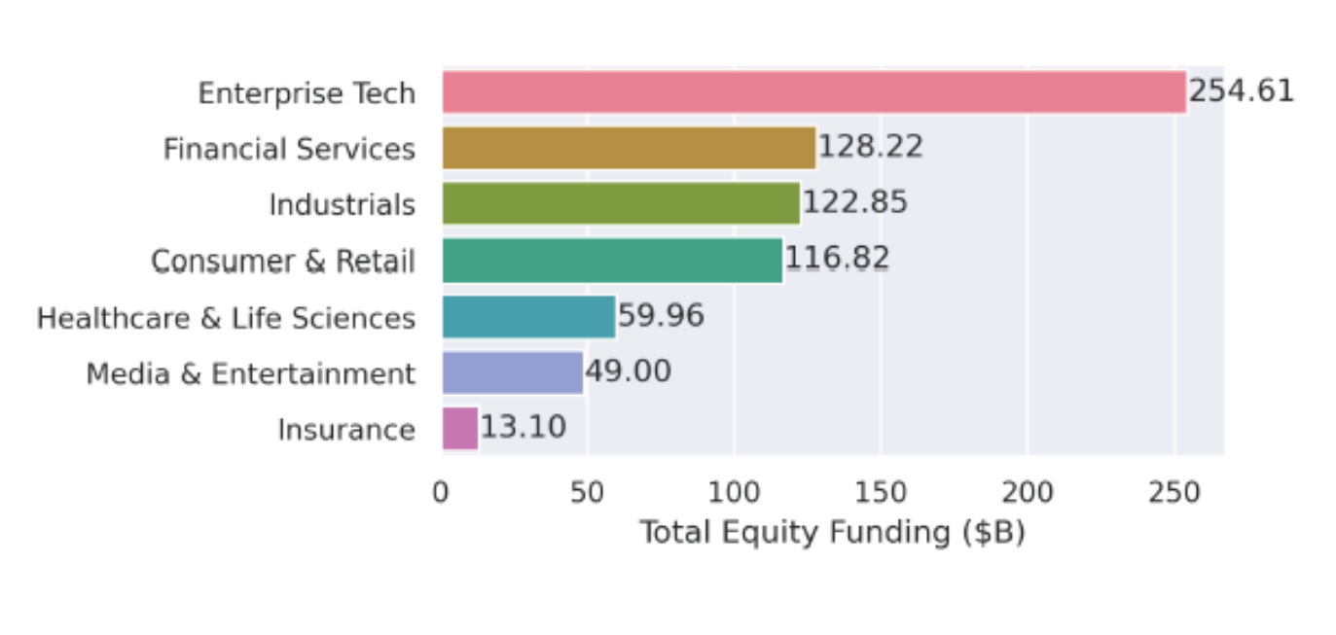

Chart Summary

| Sector | Equity Funding ($B) |
| --- | --- |
| Enterprise Tech | 254.61 |
| Financial Services | 128.22 |
| Industrials | 122.85 |
| Consumer & Retail | 116.82 |
| Healthcare & Life Sciences | 59.96 |
| Media & Entertainment | 49.00 |
| Insurance | 13.10 |

Key Insights

1. Enterprise Tech Dominates

* With $254.61B, Enterprise Tech has received nearly double the funding of the next closest sector.
* This reflects the massive investor appetite for cloud infrastructure, SaaS, AI platforms, and enterprise automation.

2. Strong Investment in Financial Services & Industrials

* Financial Services ($128.22B) and Industrials ($122.85B) are close contenders.
* Fintech continues to attract capital due to digital banking, payments, and blockchain.
* Industrials likely include robotics, logistics, and manufacturing tech—areas seeing innovation and automation.

3. Consumer & Retail Still Strong

* At $116.82B, this sector remains a major draw, especially with e-commerce, D2C brands, and retail tech.

4. Healthcare & Media Are Mid-Tier

* Healthcare & Life Sciences ($59.96B) and Media & Entertainment ($49.00B) show moderate funding.
* Healthcare may be underfunded relative to its societal importance, possibly due to regulatory hurdles and longer ROI timelines.

5. Insurance Lags Behind

* Insurance ($13.10B) is the lowest-funded sector, suggesting either:
  + Fewer unicorns in insurance
  + Slower innovation pace
  + Higher barriers to disruption

Conclusion

Investors are heavily favoring sectors with scalable, high-margin, and tech-driven business models. Enterprise Tech leads the charge, while Insurance remains a niche play. The mid-tier sectors may offer untapped potential for future growth.

# 6.2 Geographical Analysis:- Top Countries by Valuation

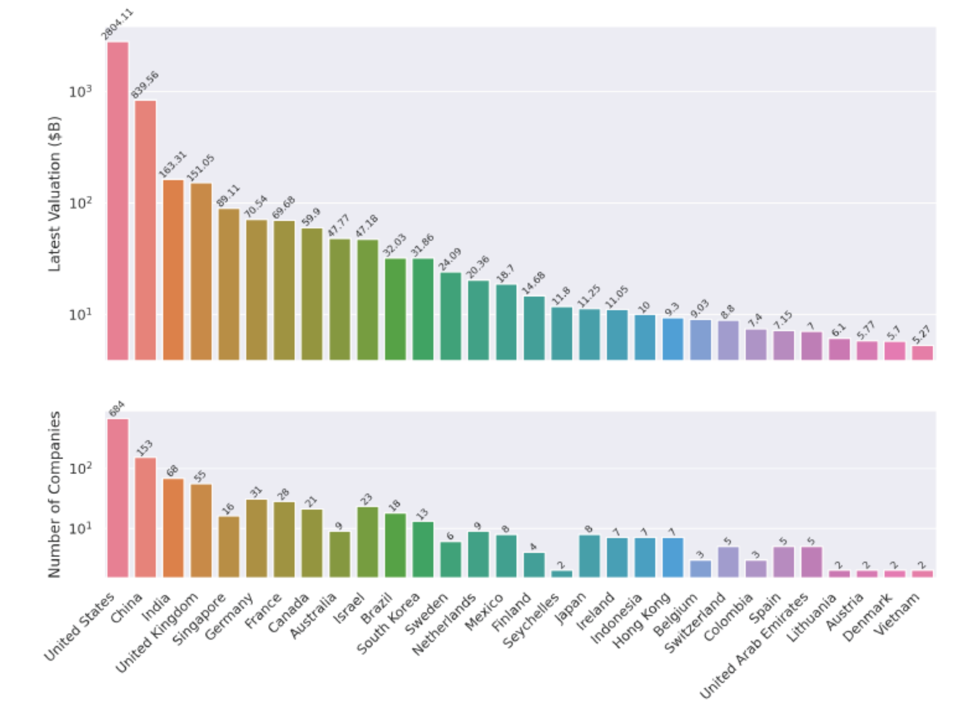

Top Countries by Startup Valuation & Company Count

Chart 1: Latest Valuation (in B$)

| **Country** | **Valuation (B$)** |
| --- | --- |
| United States | 2804.11 |
| China | 839.56 |
| India | 163.31 |
| UK | 151.05 |
| Germany | 70.54 |
| France | 69.68 |

* **The U.S. dominates** with nearly **3x** the valuation of China and over **13x** that of India.
* **China** is a strong second, but there's a steep drop-off after that.
* **Europe** (UK, Germany, France) holds a respectable middle tier.

Chart 2: Number of Companies

| **Country** | **Companies** |
| --- | --- |
| United States | 684 |
| China | 153 |
| India | 68 |
| UK | 55 |
| Germany | 31 |
| France | 28 |

* The **U.S. again leads** by a wide margin, hosting over **50%** of all companies shown.
* **China and India** follow, reflecting their growing startup ecosystems.
* **European countries** have fewer companies but still contribute significant valuation.

Key Insights

United States

* Leads in both valuation and company count.
* Suggests not just quantity but also high-value companies (e.g., unicorns, decacorns).

China

* Strong second in both metrics.
* High average valuation per company, indicating a mature and well-funded ecosystem.

India

* Fewer companies than China but still ranks 3rd in valuation.
* Indicates rising influence in global tech and startup innovation.

Europe (UK, Germany, France)

* Moderate number of companies with solid valuations.
* Suggests efficient capital deployment and possibly more late-stage companies.

Others (e.g., Israel, Brazil, Singapore)

* Smaller ecosystems but still producing high-value companies.
* May represent emerging innovation hubs.

Conclusion

* The **U.S. is the undisputed leader** in both startup volume and valuation.
* **China and India** are rapidly scaling, with China showing higher capital concentration.
* **Europe** maintains a strong presence with fewer but valuable companies.
* **Emerging markets** like Israel, Brazil, and Southeast Asia are punching above their weight in valuation per company.

# 6.3 Sector-Based Analysis (Top Sector)

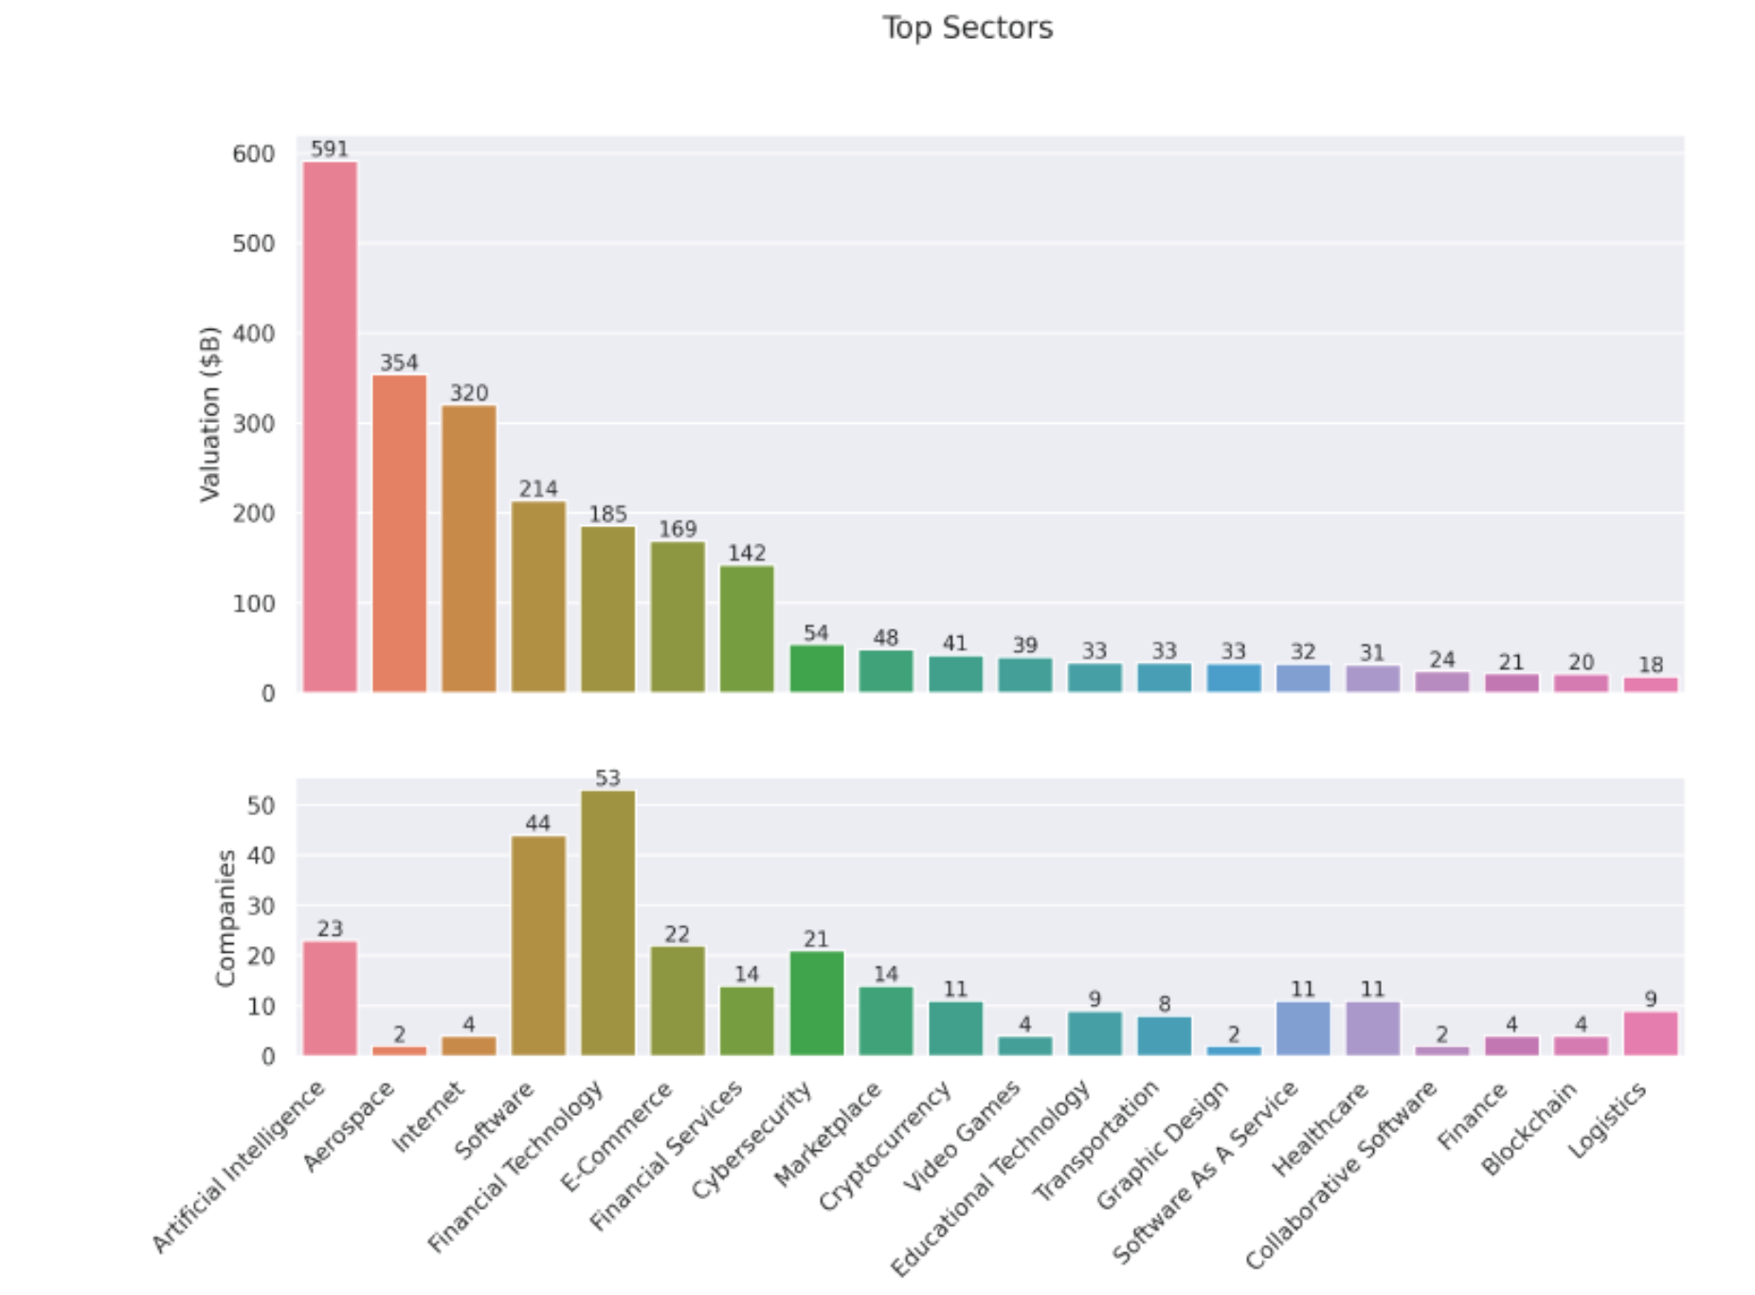

1. Chart 1: Total Valuation ($B)
2. Chart 2: Number of Companies

These charts help us understand which sectors are attracting the most capital and where the highest concentration of startups lies.

Chart 1: Total Valuation by Sector

This chart ranks sectors by the **cumulative valuation** of companies within each.

| **Rank** | **Sector** | **Valuation ($B)** |
| --- | --- | --- |
| 1 | Artificial Intelligence | 591 |
| 2 | Aerospace | 354 |
| 3 | Internet | 320 |
| 4 | Software | 214 |
| 5 | Financial Technology | 185 |
| 6 | E-Commerce | 169 |
| 7 | Financial Services | 109 |
| 8 | Cybersecurity | 142 |
| 9 | Marketplace | 54 |
| 10 | Cryptocurrency | 41 |

Insights:

* **Artificial Intelligence** leads by a wide margin, reflecting the explosive growth and investor enthusiasm in generative AI, machine learning, and automation.
* **Aerospace** and **Internet** follow, likely driven by a few high-value players (e.g., SpaceX, Starlink, or major platform companies).
* **Software, Financial Technology, and E-Commerce** show strong valuations, indicating their strategic importance in a post-pandemic, digitally connected world.

Chart 2: Number of Companies by Sector

This chart shows how many companies are active in each sector.

| **Rank** | **Sector** | **Number of Companies** |
| --- | --- | --- |
| 1 | Financial Technology | 53 |
| 2 | Software | 44 |
| 3 | Artificial Intelligence | 23 |
| 4 | E-Commerce | 22 |
| 5 | Cybersecurity | 21 |
| 6 | Financial Services | 14 |
| 7 | Marketplace | 14 |
| 8 | Cryptocurrency | 11 |
| 9 | Internet | 4 |
| 10 | Aerospace | 2 |

Insights:

* **Fintech and Software** dominate in company count, suggesting lower barriers to entry and broad applicability.
* **AI**, despite being #1 in valuation, has fewer companies—indicating high capital concentration per firm.
* **Aerospace and Internet** have very few companies but extremely high valuations, likely skewed by a few mega-unicorns.

Valuation Efficiency: Average Valuation per Company

Let’s calculate how much valuation each company commands on average:

| **Sector** | **Valuation ($B)** | **Companies** | **Avg. Valuation/Company ($B)** |
| --- | --- | --- | --- |
| Aerospace | 354 | 2 | **177.0** |
| Internet | 320 | 4 | **80.0** |
| Artificial Intelligence | 591 | 23 | **25.7** |
| Health | 167 | 20 | 8.4 |
| Biotechnology | 127 | 19 | 6.7 |
| Cybersecurity | 139 | 21 | 6.6 |
| Transportation | 132 | 17 | 7.8 |
| Software | 214 | 44 | 4.9 |
| E-Commerce | 157 | 22 | 7.1 |
| Financial Technology | 185 | 53 | **3.5** |

Conclusion

* **Artificial Intelligence is the most valuable sector overall**, with a strong average valuation per company—showing both depth and scale.
* **Aerospace and Internet** are outliers: few companies, but massive valuations—likely driven by a handful of dominant players.
* **Fintech and Software** have the most companies but the lowest average valuation per firm, suggesting high competition and market saturation.
* **Health, Cybersecurity, and Biotech** strike a balance between company count and valuation, indicating steady investor confidence.

# 6.4 Company-Based with Growth Rate Analysis

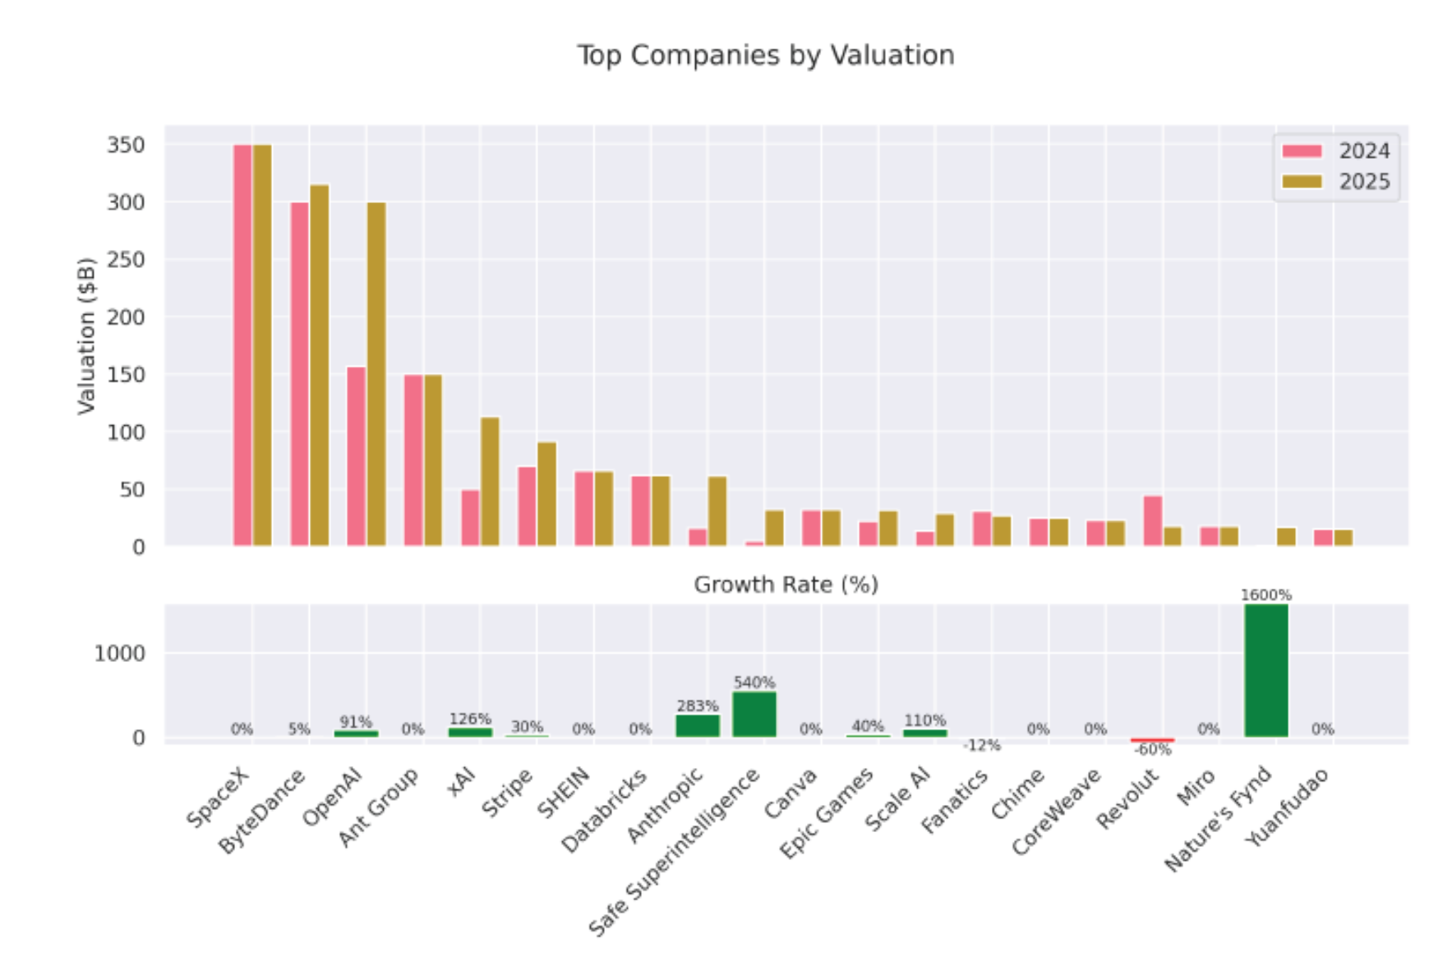

Top Companies by Valuation (2024 vs. 2025)

The upper section of the chart compares company valuations in billions of dollars:

* **Top 5 by 2025 Valuation**:
  1. **SpaceX** – remains the highest-valued company, unchanged from 2024.
  2. **ByteDance** – slight increase (~5% growth).
  3. **OpenAI** – major jump, reflecting a 91% increase.
  4. **Ant Group** – valuation remains flat.
  5. **XAI** – huge leap, up 126%.
* **Other notable players**:
  1. **Anthropic** and **Safe Superintelligence** show explosive growth.
  2. **Stripe**, **Epic Games**, and **Scale AI** also post solid gains.
  3. **Fanatics** and **Revolut** decline in valuation, with Revolut dropping sharply.

Growth Rate Highlights (Bottom Section)

| **Company** | **Growth Rate (%)** |
| --- | --- |
| Nature’s Fynd | **1600%** |
| Safe Superintelligence | 540% |
| Anthropic | 283% |
| Scale AI | 110% |
| XAI | 126% |
| OpenAI | 91% |
| Stripe | 30% |
| Epic Games | 40% |
| Fanatics | -12% |
| Miro | -60% |
| Others | 0% |

Observations:

* **AI companies dominate growth**: OpenAI, Anthropic, XAI, Scale AI, and Safe Superintelligence all post triple-digit growth.
* **Nature’s Fynd** (a biotech/alt-protein company) is the outlier with a staggering 1600% growth—possibly due to a new funding round or breakthrough.
* **Fanatics** and **Miro** are the only companies with negative growth, suggesting valuation corrections or strategic setbacks.
* Several companies (e.g., SpaceX, SHEIN, Canva, Chime) show **0% growth**, indicating stable but stagnant valuations.

Conclusion

* **AI is the clear growth engine** in 2025, with multiple companies seeing valuations more than double.
* **Nature’s Fynd** stands out as a breakout success, likely due to a major funding event or market shift.
* **Stability at the top**: SpaceX and ByteDance remain dominant but show little to no growth.
* **Caution flags**: Miro’s -60% drop and Fanatics’ decline suggest market corrections or internal challenges.

Remarks:

* 1. Nature’s Fynd自然之源是一家利用黃石國家公園的微生物生產蛋白質的食品公司，創造了肉類和乳製品替代品 這種名為「Fusarium strain flavolapis」的微生物，發酵後會生成一種富含蛋白質的物質，名為「Fy」。 Nature 's Fynd 利用 Fy 開發了諸如素食早餐餅和無奶優格等產品。
  2. Safe Superintelligence Inc. 或 SSI Inc. 是一家美國人工智慧公司，由 Ilya Sutskever（OpenAI 前首席科學家）、Daniel Gross（蘋果 AI 前負責人）和 Daniel Levy（投資者兼 AI 研究員）創立。

# 6.5 Top Investor Analysis

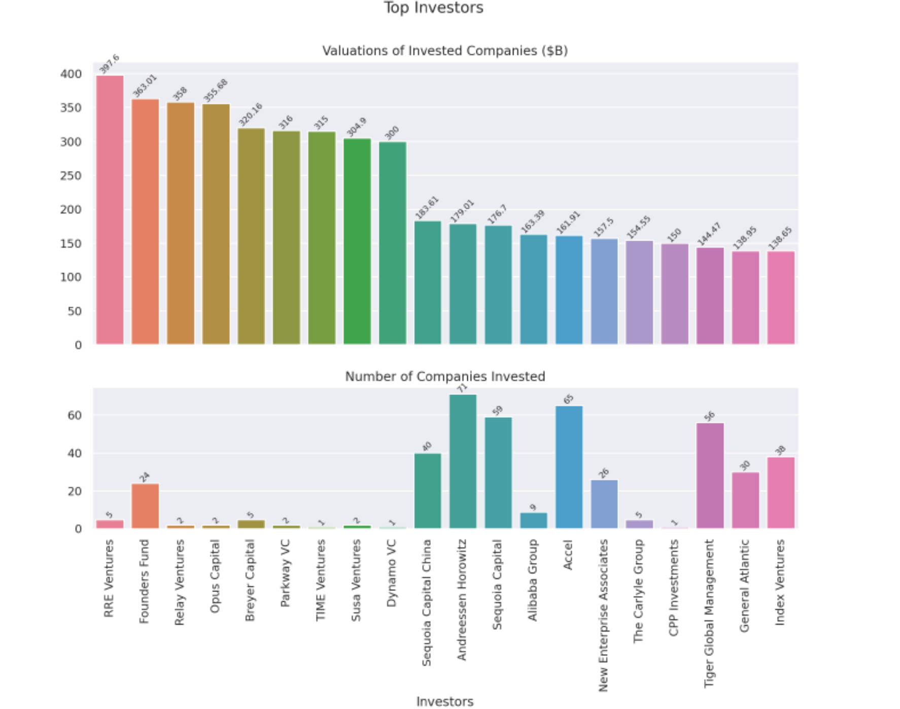

Chart 1: Valuations of Invested Companies ($B)

This chart ranks investors by the **total valuation of the companies** they’ve invested in.

Key Observations:

* **RRE Ventures** leads with $397.6B in total valuation, despite investing in only 5 companies.
* **Founders Fund**, **Relay Ventures**, and **Opus Capital** follow closely, each with over $350B in valuation.
* These top investors have relatively few investments, suggesting they backed **very high-value unicorns** (e.g., SpaceX, ByteDance, OpenAI).
* In contrast, **Andreessen Horowitz** and **Sequoia Capital** have lower total valuations ($179B and $176.7B respectively) but are known for **broad portfolios**.

Chart 2: Number of Companies Invested

This chart shows how many unicorns each investor has backed.

Key Observations:

* **Andreessen Horowitz** (71) and **Accel** (65) have the **broadest reach**, investing in dozens of unicorns.
* **Sequoia** (59), **Tiger Global Management** (56) **Sequioa Capitial China** (40) and also show strong diversification.
* **RRE Ventures**, despite leading in valuation, has only 5 investments—suggesting **high-conviction, high-impact bets**.
* **Time Venture** has only 1 investment, but it contributes significantly to its valuation total ($315B), indicating a **single mega-unicorn**.

Conclusion

The charts reveal two dominant investment strategies: **concentrated bets on mega-unicorns** (e.g., RRE Ventures, Founders Fund) and **broad diversification across many startups** (e.g., Sequoia Capital, Andreessen Horowitz). Both approaches can yield high returns, but the former relies on picking outliers, while the latter spreads risk across the ecosystem. For founders, this also signals which investors are more likely to back early-stage moonshots versus those who scale proven models.

# 6.6 Top Founder Analysis

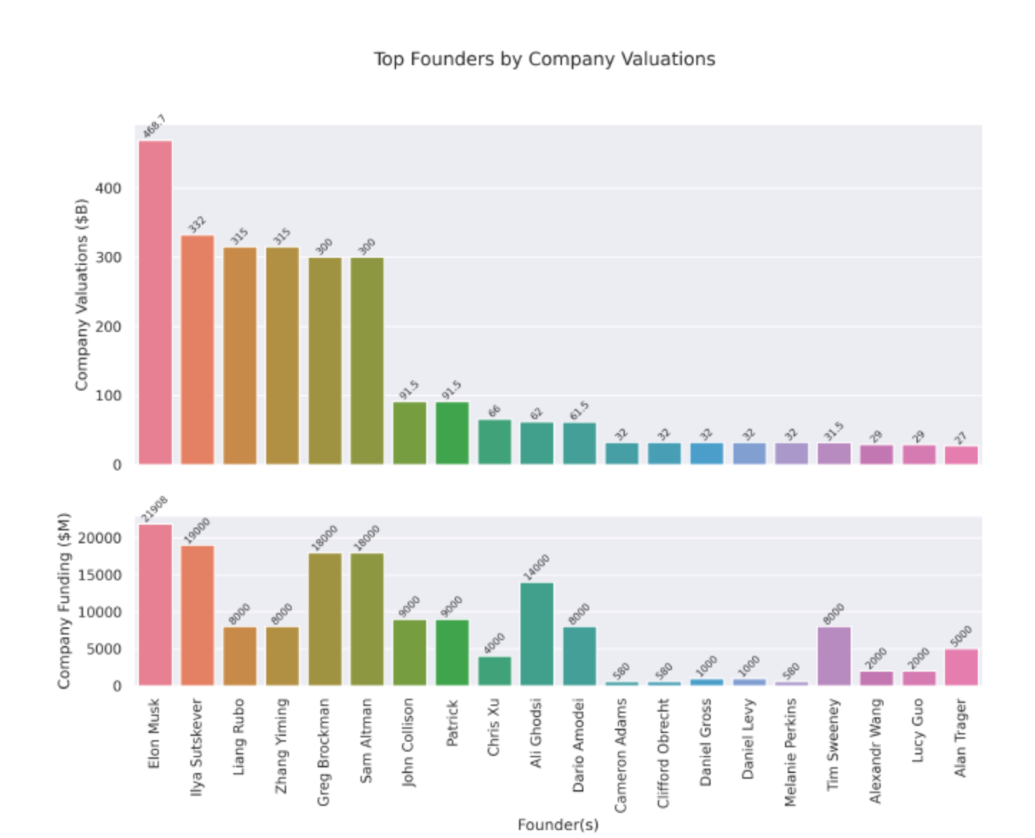

Key Observations

* **Recent Founders, Massive Valuations:**   
  Companies founded between **2010–2016** dominate the high valuation range (above $10B–$50B). This period seems to be a hotbed for unicorn creation, especially in tech and finance.
* **Outliers Like SpaceX & ByteDance:**   
  These companies—though founded earlier (e.g., early 2000s)—show exceptionally high valuations **($300B–$350B)**, suggesting longer-term strategic growth, continual funding, and massive scale.
* **Quick Climbers:**   
  Some unicorns founded in the **past 5 years** (2020 onward) like **Anthropic, xAI, and Perplexity** are already seeing multi-billion dollar valuations (approaching or crossing $10B), implying investor excitement in emerging tech like AI.
* **Clustering:**   
  There’s a noticeable clustering of unicorns with valuations ranging between **$10B–$30B**, particularly among those founded between **2012–2018**. It reflects a time when VC funding surged and industries like fintech, SaaS, and retail tech boomed.

Conclusion

* The last decade has been fertile ground for unicorn growth, especially in AI, fintech, and enterprise software.
* **Younger unicorns** reaching high valuations quickly (within 2–4 years) point to evolving investor behavior—favoring disruptive innovation over long-term scaling.
* Legacy unicorns (early 2000s) reaching peak valuations underline the **power of sustained growth and strategic reinvention**.

# 7. Time-Based Analysis

**7.1.1 Unicorn Growth Over Time**

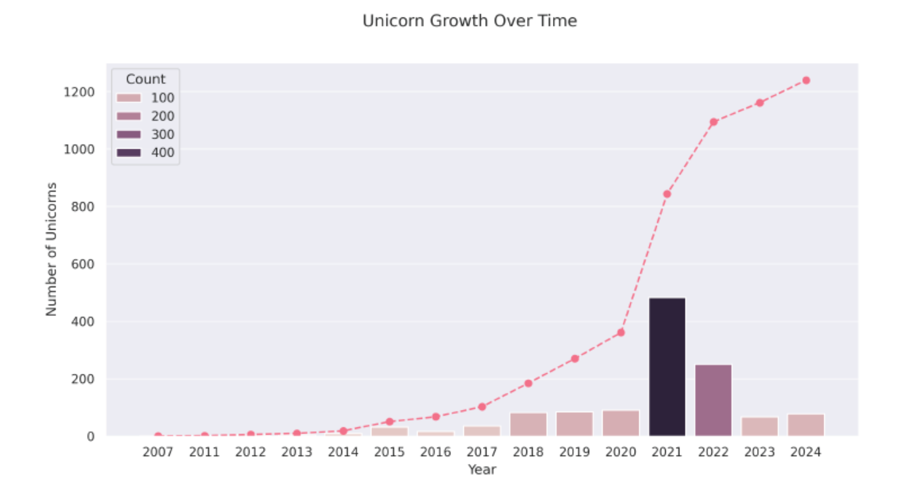

Graph Analysis: Unicorn Growth Over Time (2007–2024)

🔹Cumulative Growth (Line with Pink Dots)

* **Flat growth from 2007–2013**: Unicorn formation was rare during this period.
* **Acceleration begins in 2014**, and continues steadily until a surge around **2020–2021**.
* **Peak jump in 2021**: The cumulative count leaps sharply, indicating a unicorn explosion.**1**
* **2022–2024**: Growth continues but at a slower rate—still upward, but less steep.

🔹 New Unicorns Per Year (Bar Graphs)

* **Pre-2014**: Fewer than 50 new unicorns annually.
* **2014–2019**: Gradual rise, reaching over 100/year.
* **2020 spike**, and **2021 peaks at 400** new unicorns—the largest single-year influx.
* **Post-2021 decline**: 2022 and 2023 show reduced activity, likely under 200/year.
* **2024 stabilizes**: Slight rise or plateau, but nowhere near the 2021 explosion.

Interpretation & Trends

* **2021 Boom Year**: Fueled by pandemic-driven digitization, remote work tech, fintech surges, and unprecedented Venture Capital (VC) liquidity.
* **2022–2023 Dip**: Global macroeconomic tightening, interest rate hikes, and VC pullback likely dampened unicorn formation.
* **Resilience**: Despite the slowdown, the ecosystem is still producing unicorns annually and the cumulative count is robust.
* **Shift in Investment Strategy**: Post-2021, investors are favoring **quality over quantity**, leading to fewer but more strategically backed startups.

Conclusion

The graph illustrates a dramatic inflection point in unicorn growth centered on 2021—marking it as the peak of the startup funding era. While subsequent years show a correction, the overall trend remains positive. The unicorn landscape is maturing, with greater emphasis on sustainability and impact. For entrepreneurs, the takeaway is clear: it’s still possible to build billion-dollar businesses—but the road is more disciplined and competitive than ever.

Note 1: Peak jump in 2021

1. VC Capital Overflow

* Venture capital firms had **record-breaking** available investment funds.
* Low interest rates drove investors away from traditional assets and into **riskier startups** for higher returns.

2. Pandemic-Driven Digital Acceleration

* COVID-19 radically changed consumer behavior:
  + Remote work → enterprise SaaS boom
  + E-commerce → massive growth in logistics and fintech
  + Telemedicine & health tech adoption soared
* Startups solving pandemic-era problems were suddenly indispensable.

3. AI & Deep Tech Investment Wave

* Major breakthroughs in AI attracted billion-dollar valuations.
* Companies like **OpenAI**, **Databricks**, and **UiPath** were riding high on automation and data science trends.

4. SPAC Mania & IPO Pipeline

* 2021 saw a boom in **SPACs** (Special Purpose Acquisition Companies).
* Many unicorns were prepping to go public, inflating private valuations in anticipation.

5. Globalization of Startup Ecosystems

* Unicorn creation wasn't just a Silicon Valley story anymore:
  + India, Southeast Asia, and Africa saw a **surge in startup success**
  + Government tech incentives and maturing ecosystems helped fuel growth

6. Fear of Missing Out & Deal with uncontrolled and excited behaviour

* Investors feared **missing out** on breakout success stories.
* Result: faster deal cycles, inflated valuations, and aggressive funding rounds — sometimes within weeks!

**Summary**

The unicorn boom of 2021 was fueled by a rare combination of cheap money, digital urgency, and investor exuberance. It was the startup world’s equivalent of a gold rush — high stakes, high velocity, and high rewards. While the pace has slowed, the ripple effects continue, especially in deep tech and AI, setting the stage for the next wave of innovation.

**7.1.2 Time to Unicorn**

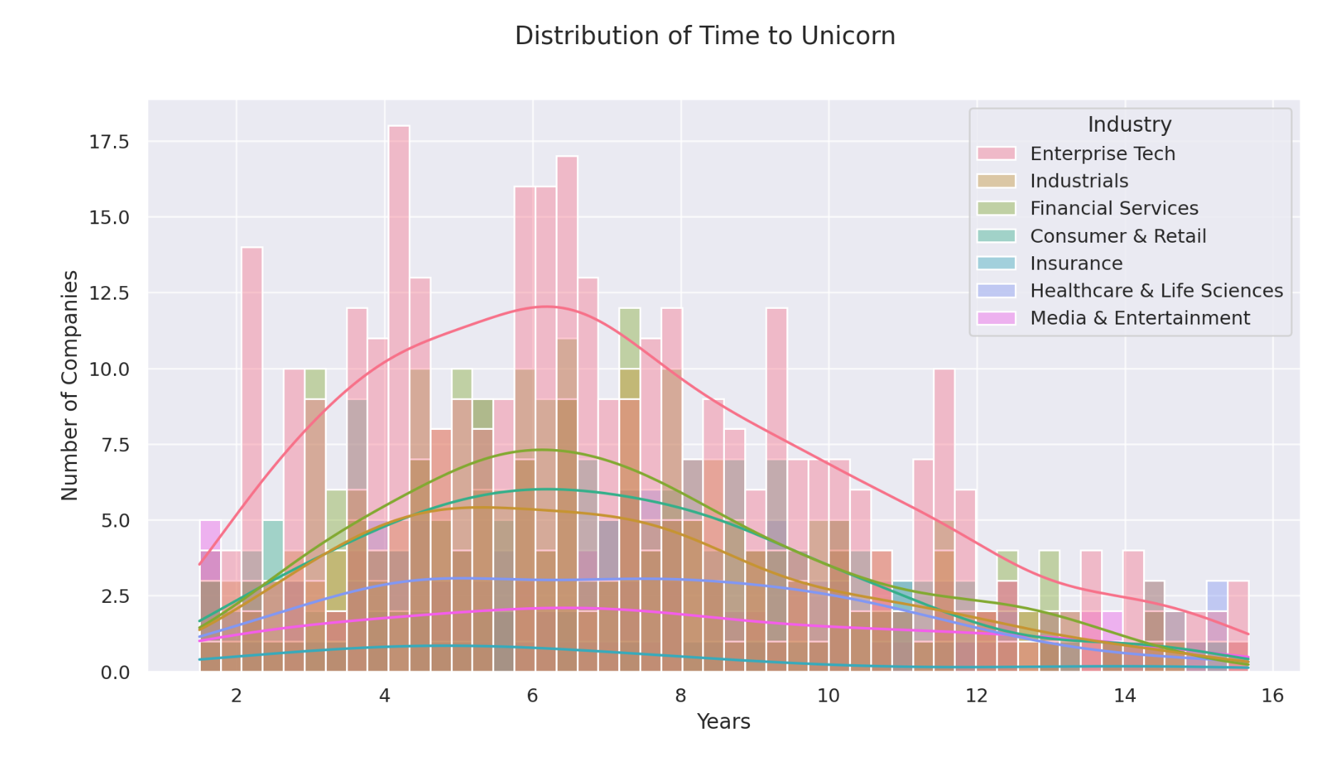

Graph Overview

**X-axis**: Years taken to become a unicorn (0–16 years)  
**Y-axis**: Number of companies hitting unicorn status within that timeframe  
**Color-coded sectors**:

* Enterprise Tech (pink)
* Industrials (brown)
* Financial Services (green)
* Consumer & Retail (light blue)
* Insurance (cyan)
* Healthcare & Life Sciences (purple)
* Media & Entertainment (magenta)

The graph combines **stacked bar charts** with **smoothed density curves**, giving both distribution and trend visibility across industries.

Key Insights

1. Fastest Growth Window: 2–6 Years

* The bulk of unicorns emerge within this span—especially in Enterprise Tech, Consumer & Retail, and Financial Services.
* Suggests these sectors have scalable models, shorter product-market fit cycles, and aggressive funding environments.

2. Enterprise Tech Dominates Early Success

* Large concentration between years 2–4.
* These companies often leverage SaaS and B2B platforms, which allow fast user acquisition and predictable revenue growth.

3. Industrials and Healthcare Take Longer

* Visible presence beyond 6 years.
* These sectors face more regulatory hurdles, capital demands, and infrastructure requirements.

4. Long Tail of Growth (10+ years)

* A small but notable portion of companies take over a decade to reach unicorn status—especially in Healthcare and Industrials.
* These likely reflect deep tech, biotech, and energy startups with prolonged R&D cycles.

Conclusion

The graph reveals that while most unicorns rise swiftly within 2–6 years, the time to reach that milestone varies dramatically by industry. Enterprise Tech and Consumer/Retail thrive on speed and scalability, whereas Healthcare and Industrials follow slower, more deliberate paths. Understanding this timeline helps investors calibrate expectations—and reminds founders that patience, not just velocity, can lead to billion-dollar valuations.

# 8. Survival and Acquisition

8.1.1 Top Exited Unicorns as of March 2022

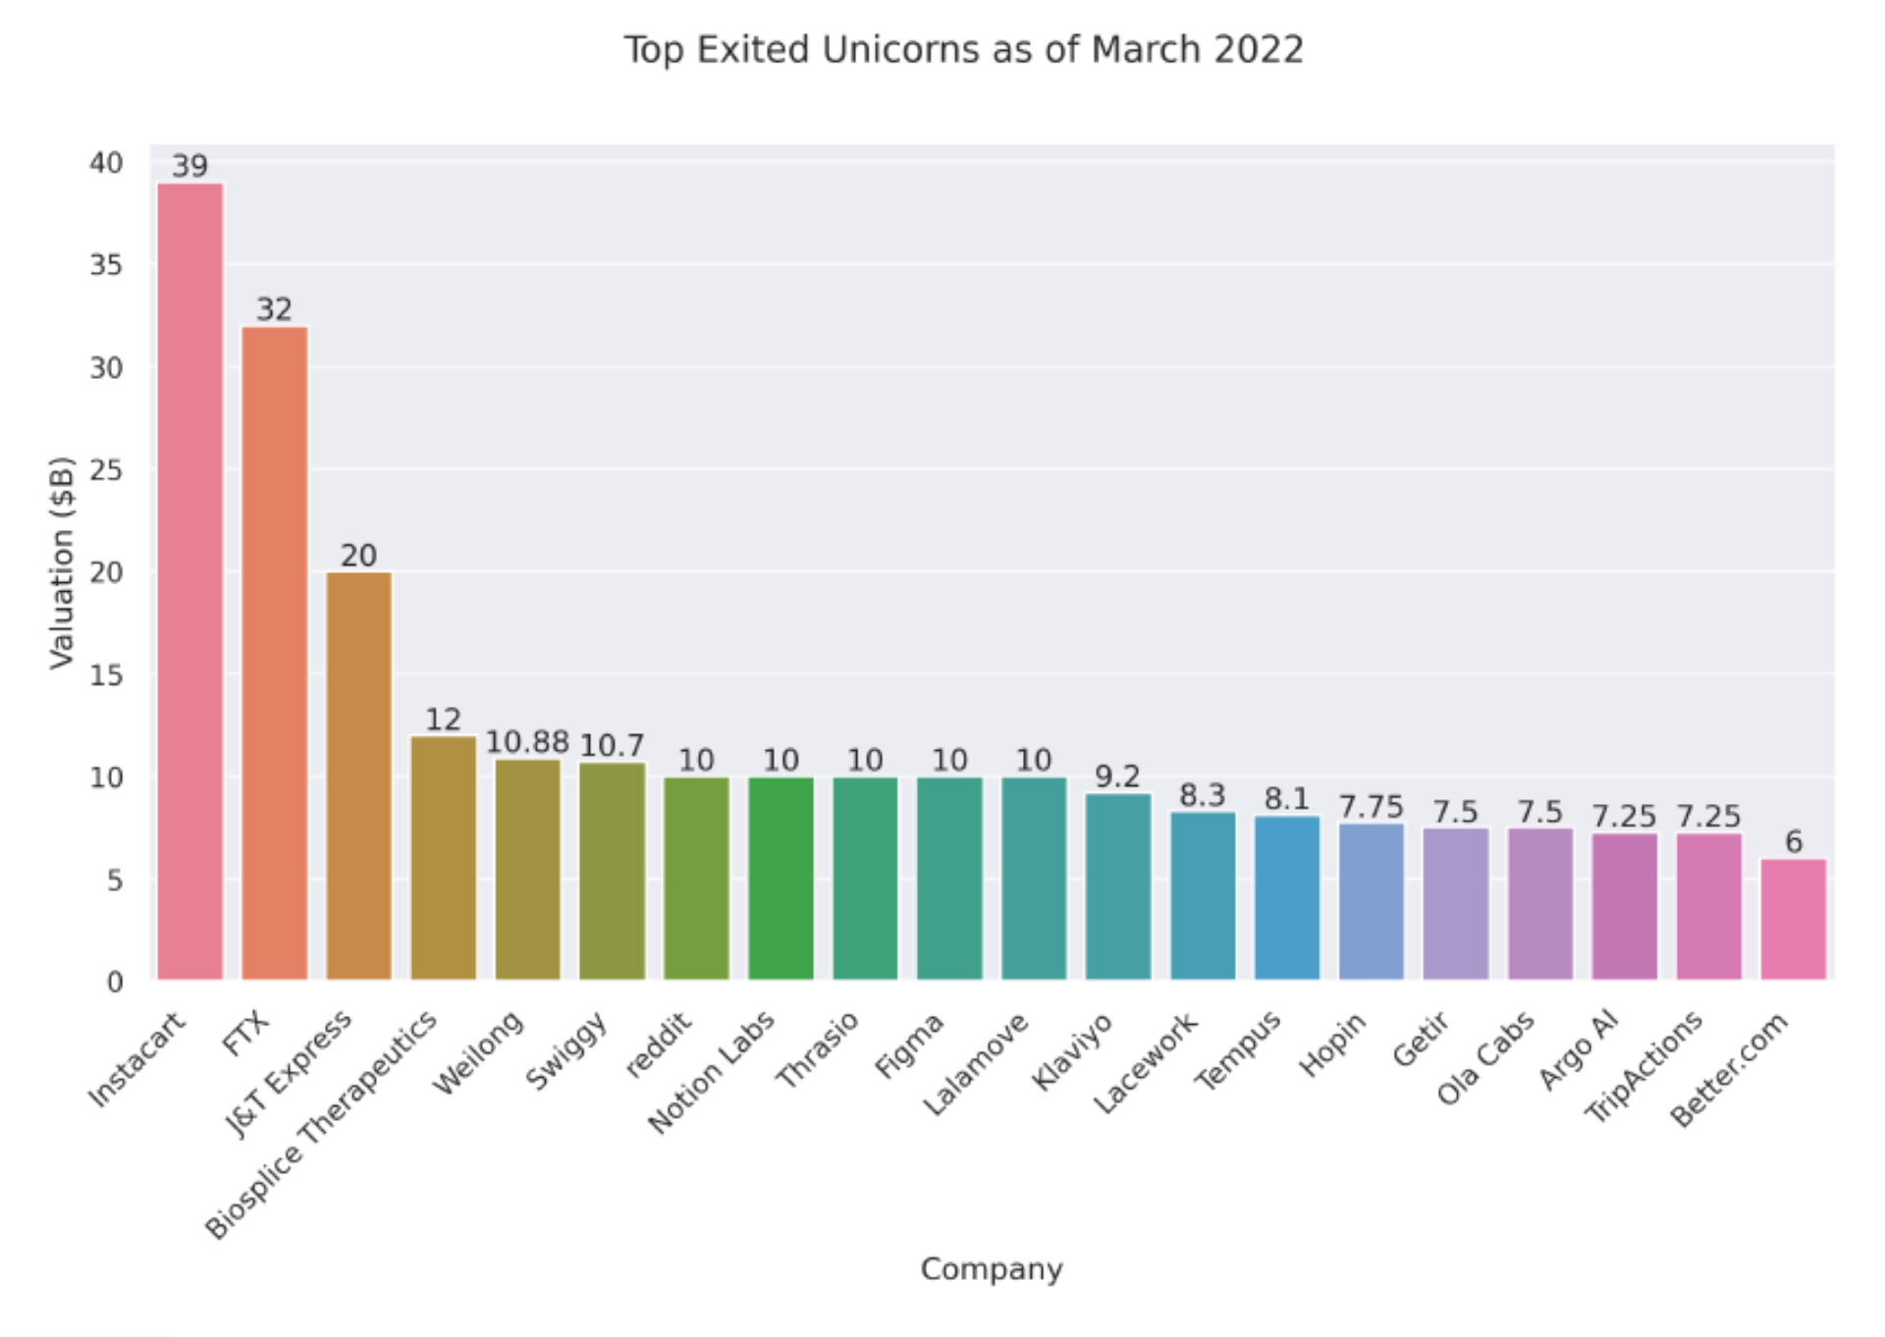

Graph Analysis: Top Exited Unicorns

**🔹** 1. Instacart ($39B)

* Leads the chart with the highest exit valuation.
* Its surge reflects pandemic-driven demand for grocery delivery and scalable logistics tech.

**🔹** 2. FTX ($32B)

* Very high valuation for a crypto exchange — notable considering its later collapse.
* Illustrates the dramatic rise (and volatility) of crypto-driven unicorns during 2020–2021.

**🔹** 3. J&T Express ($20B)

* Logistics giant from Asia, likely benefiting from booming e-commerce demand across emerging markets.

**🔹** 4–11. Clustered $10B Unicorns

* Includes Weilong, Swiggy, Reddit, Notion Labs, Thrasio, Figma, Lalamove, and Klaviyo.
* Represents a diverse range of industries: productivity software, social media, logistics, and retail aggregation.
* These companies show that **niche platforms and regional players** can achieve massive exits with strong business models.

**🔹** 12–20. Valuations Between $6B–10B

* Includes Lacework (cybersecurity), Tempus (health tech), Hopin (event tech), Ola Cabs (mobility), and Better.com (real estate fintech).
* Reflects the long tail of highly valued but slightly more specialized unicorns.

Conclusion

The graph demonstrates that unicorn exit valuations peaked across **a variety of sectors**, but logistic platforms, consumer tech, and digital infrastructure dominated. While some names have since faced turbulence (e.g., FTX), their inclusion reflects the 2021–2022 exuberance around scalable tech. For startup founders, the lesson is clear: **solving real-world problems with digital precision** remains the most viable path to high-value exits.

**8.1.2 Exit Reasons of Former Unicorns**

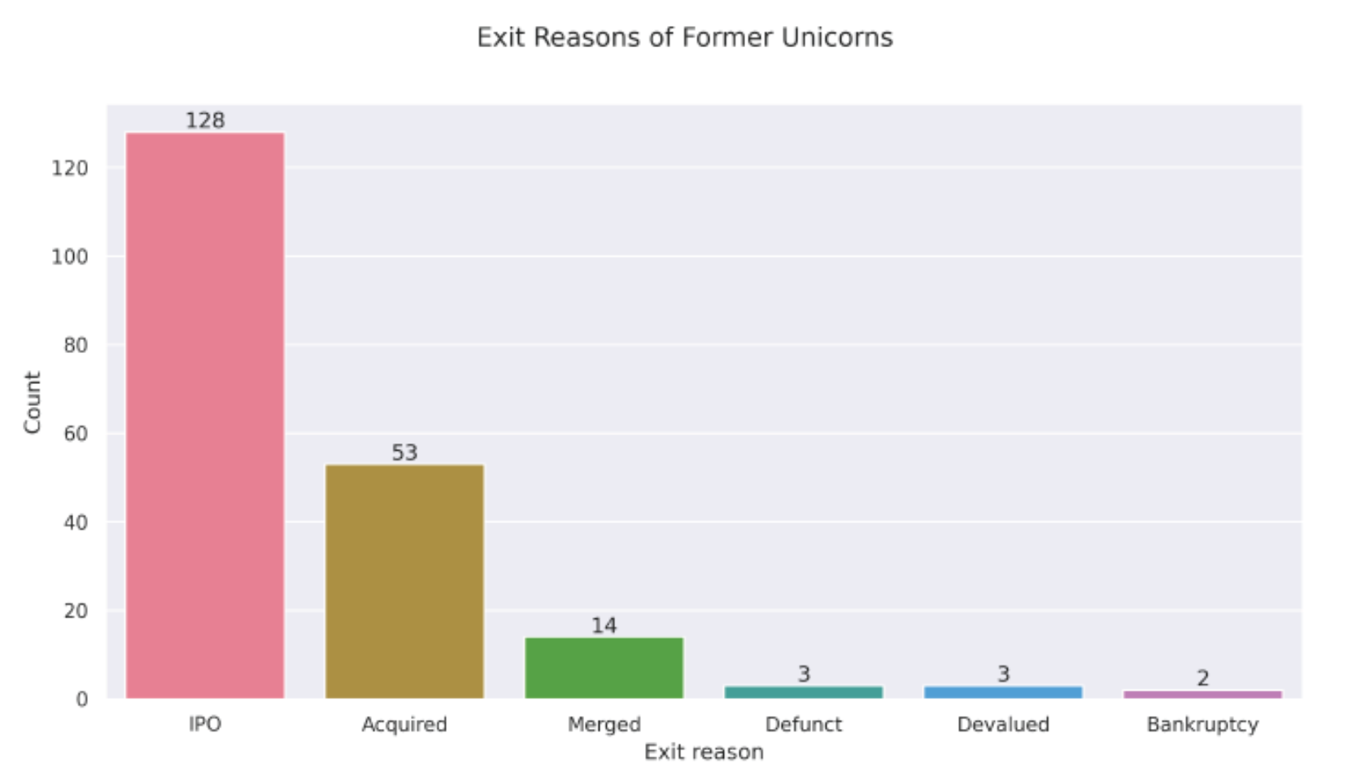

Graph Breakdown: Exit Pathways for Unicorns

Key Categories and Counts

|  |  |
| --- | --- |
| Exit Reason | Count |
| IPO | 128 |
| Acquired | 53 |
| Merged | 14 |
| Defunct | 3 |
| Devalued | 3 |
| Bankruptcy | 2 |

Insights

1. IPO Is the Dominant Exit Route

* With **128 unicorns** going public, IPO remains the most desirable and common path.
* Indicates strong investor demand and market confidence in high-growth startups.

2. Acquisition Is the Second Most Common

* **53 companies** were acquired, showing that many unicorns become attractive targets for strategic buyers.
* Acquisition often offers faster liquidity and operational synergies.

3. Mergers Are Less Prevalent

* Just **14 unicorns** opted for mergers—usually to combine tech stacks, expand markets, or survive competition.
* Less common, but may result from stagnation or strategic realignment.

4. Rare and Risky Outcomes

* **Defunct, Devalued, and Bankruptcy** represent failure or decline — with a total of just **8 companies**.
* These outliers serve as cautionary tales of overvaluation, mismanagement, or harsh market shifts.

Conclusion

The graph clearly shows that most unicorns either go public or get acquired—affirming that high-growth startups typically succeed in securing a strategic or financial exit. However, the small tail of failures reminds us that not all billion-dollar valuations are sustainable. For entrepreneurs and investors, focusing on product-market fit, governance, and timing is essential to avoid being part of the exception.

# 9. Significance

This project demonstrates proficiency in Python-based data analysis and visualization, showcasing the ability to transform raw data into actionable insights. By analyzing unicorn companies, the project contributes to understanding the dynamics of high-growth startups, which are critical to innovation and economic development. The visualizations will serve as powerful tools for communicating findings to stakeholders, supporting strategic decision-making in investment, entrepreneurship, or policy development.

# 10. Conclusion

This project used Python to explore how big, fast-growing startup companies—called **unicorns**—work and grow around the world. We cleaned data, made charts, and found useful patterns in things like funding, industries, countries, founders, and exit strategies.

Key Points:

* **Tech rules**: Most unicorns are in enterprise tech and finance—things like software, cloud, AI, and fintech.
* **The U.S. is the leader**: America has the most unicorns and the highest total value.
* **AI companies grow fast**: Even with fewer startups, AI companies have huge valuations, showing strong demand.
* **Two types of investors**: Some pick a few winners, others spread their bets across lots of startups.
* **Most unicorns grow quickly**: Many reach a $1B value in 2 to 6 years, especially in tech.
* **Going public (IPO) is most popular**: Most unicorns exit through IPOs or being acquired—only a few fail.
* **2021 was a record year**: Thanks to digital change and lots of available cash, that year saw the most unicorns created.

In short, this project helped us understand how startups become unicorns, where money goes, and what investors care about. It also showed how Python can turn data into smart, useful stories.

**The End**